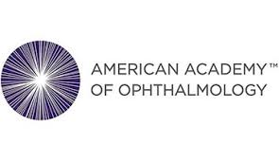
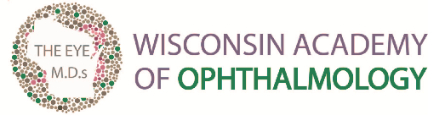

Contact: May 16, 2023
Eric Ostermann, Association Director
(920) 560-5645; or wao@badgerbay.co

The Health Exam You Didn’t Know You Needed

The Wisconsin Academy of Ophthalmology and the American Academy of Ophthalmology say blindness is often preventable with regular exams

Kimberly, WI – If you’re like most Americans surveyed in a recent Harris Poll, you probably thought you would notice a change in your vision if you had an eye disease. The fact is some of the leading causes of blindness—such as glaucoma or diabetic retinopathy—can begin without any symptoms. That’s why the Wisconsin Academy of Ophthalmology and the American Academy of Ophthalmology urge all healthy adults to get an eye exam at age 40, even if their vision seems fine. Early signs of disease and changes in vision may start to happen at this age.

“Patients routinely overlook the need to schedule eye exams, but it is a mistake that could have long-term health consequences. Unfortunately, many visions problems are initially unnoticeable, and if not treated in a timely manner can permanently damage your vision,” said David Nash, M.D., President of the Wisconsin Academy of Ophthalmology. “It’s important to note that eye exams can also play a role in the overall health of a patient and can help detect serious health conditions outside those that impact eyesight. I would strongly encourage healthy adults over 40 to schedule regular eye exams.”

Need more motivation to have your eyes examined? Here are four good reasons to see an ophthalmologist:

- Your brain adapts to vision loss, making some eye diseases go unnoticed until it is too late. Once vision is lost, it cannot be restored. Ophthalmologists can spot eye disease before vision is compromised and protect your sight.

- Seeing an ophthalmologist can improve not just your eye health, but your overall health. Because the blood vessels and nerves in your eye are reflective of the rest of your body, ophthalmologists are sometimes the first to diagnose diseases such as diabetes, multiple sclerosis, or vitamin deficiencies.

- Your eye health is dependent on different factors, including family history, ethnicity, age, and overall health. An ophthalmologist can help evaluate your personal risk factors and recommend the best steps for disease prevention.

- Eye disease is also a looming problem for the U.S. healthcare system. As our population ages, the number of people afflicted with vision loss is expected to double by 2050.

“Even if you think you have 20/20 vision, set up a time to get your eyes checked. It may save your sight,” said Dianna Seldomridge, M.D., clinical spokesperson for the American Academy of Ophthalmology.

For more tips and information, visit www.eyesmart.org.

About the Wisconsin Academy of Ophthalmology
The Wisconsin Academy of Ophthalmology (WAO) is a professional medical society comprised of Wisconsin ophthalmologists (medical eye doctors) who are committed to promoting quality eye care for the citizens of Wisconsin by providing its members with resources including professional education, legislative advocacy, and membership services to enhance the practice of ophthalmology in Wisconsin.

###

